**Sequelize Command:**

**Seqeulize CLI:**

npm install –save-deb sequelize-cli

**How to generate migrations, models folder in project:**

npm install --save sequelize

npx sequelize-cli init

**New file at root directory:**

For create migration, models, or seeders we first need to create a file at root directory where we define our **paths** mean where migration or models will be created when we run command for create them.

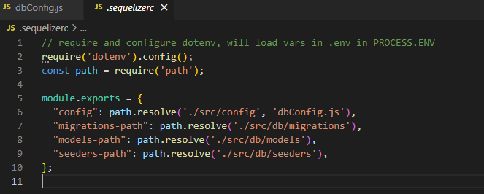

**Migration:**

npx sequelize-cli migration:generate --name migration-name

**Running Migration: (**How to run migration**);**

npx sequelize-cli db:migrate

**Create Alter Migration:**

How to add column in existing table using migration?

In Up section:

await queryInterface.addColumn('patients', 'pharmaciesId',{

      type:Sequelize.UUID,

      references:{

        model:'pharmacies',

        key:'id'

      }

    });

In Down Section:

await queryInterface.removeColumn('patients', 'pharmaciesId')

**Seeders:**

If we want to give table to anyone then they can add it’s own entry.

Like:

 {

        id: '956bb347-63c2-420f-94d3-e8e55e6d149e',

        name: 'New South Wales',

        to: '2914',

        from: '0200',

        createdAt: new Date(),

        updatedAt: new Date(),

        code: 'NSW',

      },

Command:

npx sequelize-cli seed:generate –name seader-name

Run All the seeder.

npx sequelize-cli db:seed:all

For run specific seeder.

npx sequelize-cli db:seed –seed seed-name

Note:

When we run npx sequelize-cli db:seed:all this command multiple times then it put same data multiple time in our db.

**For undo Seeder:**

In undo case **down** function is run.

down: async (queryInterface, Sequelize) => { // eslint-disable-line no-unused-

     */

    await queryInterface.bulkDelete('States', null, {});

  },

npx sequelize-cli db:seed:undo:all

**Query Interface:**

Is used for create table, add column, change column, delete column, delete database in table etc.

await queryInterface.addColumn('patients', 'pharmacyId',{

      type:Sequelize.UUID,

      references:{

        model:'pharmacies',

        key:'id'

      }

    });

**Hooks:**

Hooks (also known as lifecycle events), are **functions which are called before and after calls in sequelize are executed**. For example, if you want to always set a value on a model before saving it, you can add a before Update, before Create, after Create, After Update etc hook.

**Where we use hook:**

We use hooks in **model** as third parameter. We can use hooks in two ways.

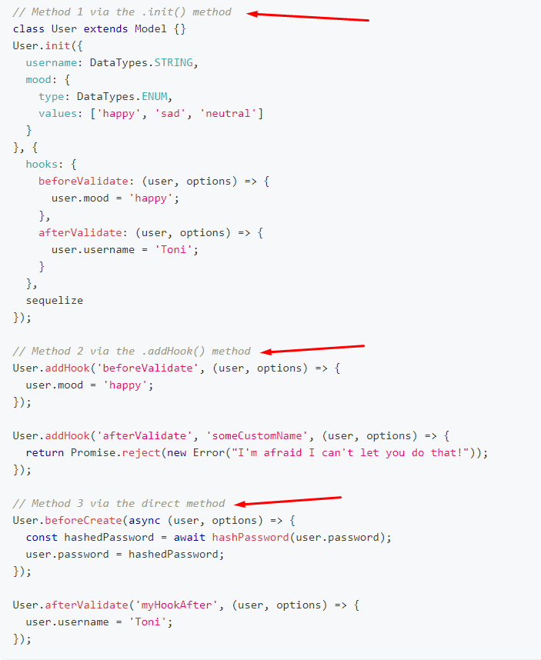

**Validation and Constraints:**

**Constraints:**

Condition at SQL level mean email entry must be not null or any other validation at sql level;

Define in model

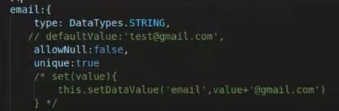

**Validation:**

Sequelize level validation. Mean name send in db should be alphabetically like use in JavaScript.

**Transections:**

Sequelize executes the callback, passing t into it. If the callback throws an error, Sequelize will automatically roll back the transaction & If the callback succeeds, Sequelize will automatically commit the transaction.

Mean If we want to insert some data in two tables if one table data inserted and other one is not then it roll back the inserted data in first table.